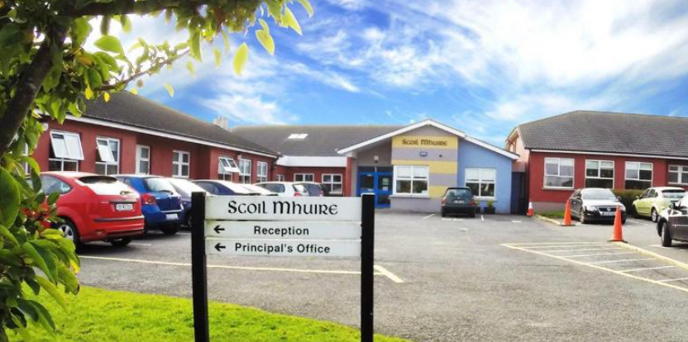

SMC Code of Behaviour
Home-School Agreement 2025-2026

Our Code of Behaviour focuses on a positive school community which promotes a welcoming, safe, caring and inclusive environment for all. As a parent/guardian, your support is very important in helping your child to understand and follow this code.

As a school we strive to
- Care for our pupils’ safety and happiness

- Show respect to all and promote positive relationships
- Help our pupils to understand how and why everyone should behave well in school
- Listen to our pupils when they are finding something hard to understand
- Help our pupils to learn in the best way that they can and do their best
- Be flexible in supporting our pupils’ behavioural and learning needs
- Provide a broad and balanced curriculum
- Communicate progress and any concerns regarding behavioural and/or learning needs to parents/ guardians. Pupils may receive Dojo points, Golden Time, certificates and go on class trips/ tours.
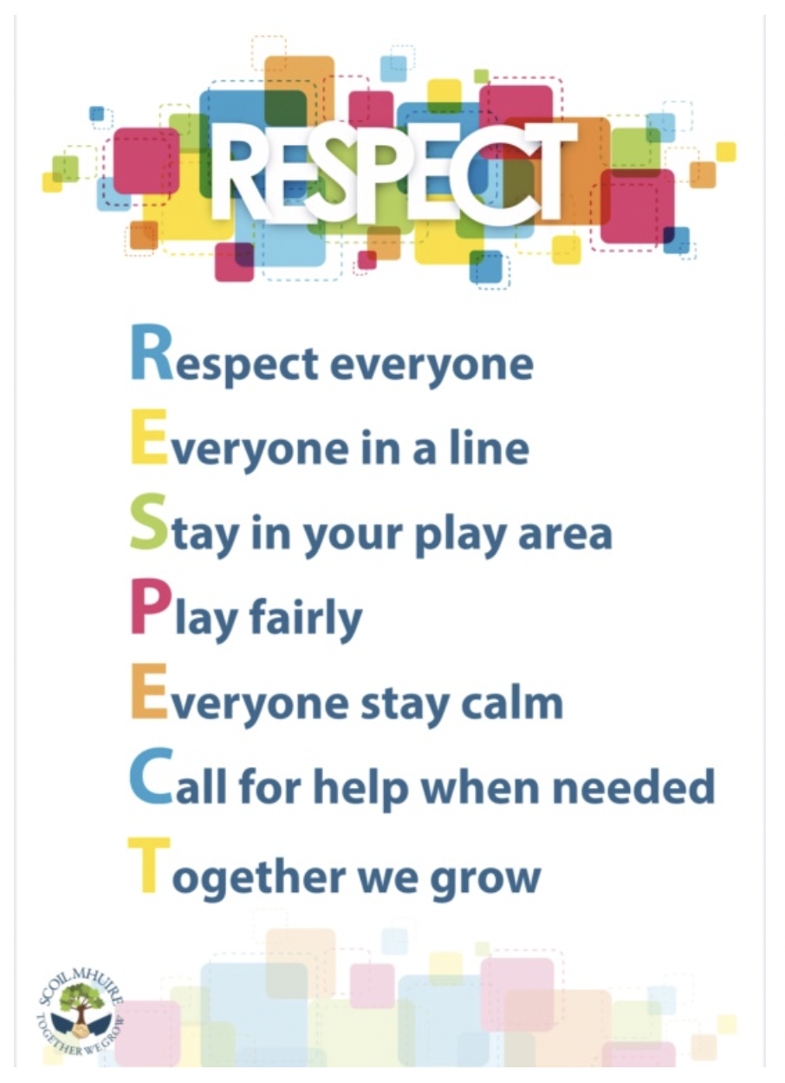
All pupils are expected to
- Be on time for school
- Wear the full school uniform. (Summer - knee length navy shorts)
- Ear-studs only. Other piercings are not advised for health and safety reasons, taping will
be required.
- Show respect and speak kindly towards all peers, adults and school community
- Remember to use good manners by saying “Please”, “Thank you”, etc.,
- Be fair, kind, gentle and inclusive on the yard/AWS, follow the RESPECT Code
- Take responsibility for my actions and respect property (school or personal)
- Show forgiveness
- Listen to others/adults when they make suggestions, offer help or give advice or instruction
- Take part in all activities as best I can
- Do homework as best I can
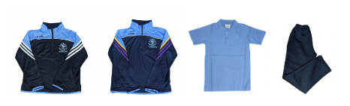
- Celebrate and be proud of all I do

As a parent/guardians I will
- See that my child goes to school everyday and on time
- See that my child wears the school uniform. Ear-studs only. Other piercings are not advised for health and safety reasons, taping will be required. (Summer - knee length navy shorts)
- Encourage my child to be independent and carry their own belongings
- Encourage my child to care for personal needs and belongings (coats, lunch boxes, water bottles etc.)
- Support my child with homework
- Make an appointment through the office to let the school know of any queries or questions
- Send a message on Dojo or contact the school office if my child is not in school
- Communicate with the teacher via Dojo and understand during the day the teacher is teaching and will respond in a timely manner
- Speak kindly towards all children, adults and school community
Our Code of Behaviour is communicated via The Home School Agreement and the Code of Behaviour Policy which is available through the school website https://coolcotts.com/code-of-behaviour.
Thank you for your support and participation in our Code of Behaviour.

