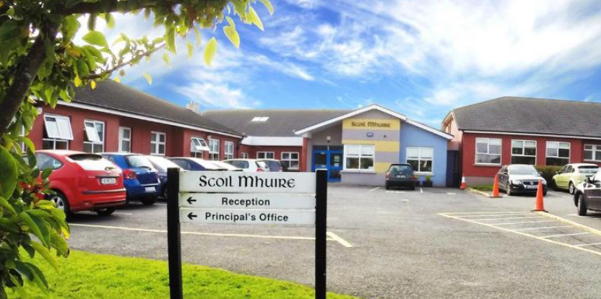

SMC Code of Behaviour
Pupil-School Agreement 2025-2026

When I go to school, I will try my best to follow the school rules so that the school community and I can learn in a welcoming, safe and caring environment.

As a school we strive to
- Care for our pupils’ safety and happiness
- Show respect to all and promote positive relationships

- Help our pupils to understand how and why everyone should behave well in school
- Listen to our pupils when they are finding something hard to understand
- Help our pupils to learn in the best way that they can and do their best
- Be flexible in supporting our pupils’ behavioural and learning needs
- Provide a broad and balanced curriculum
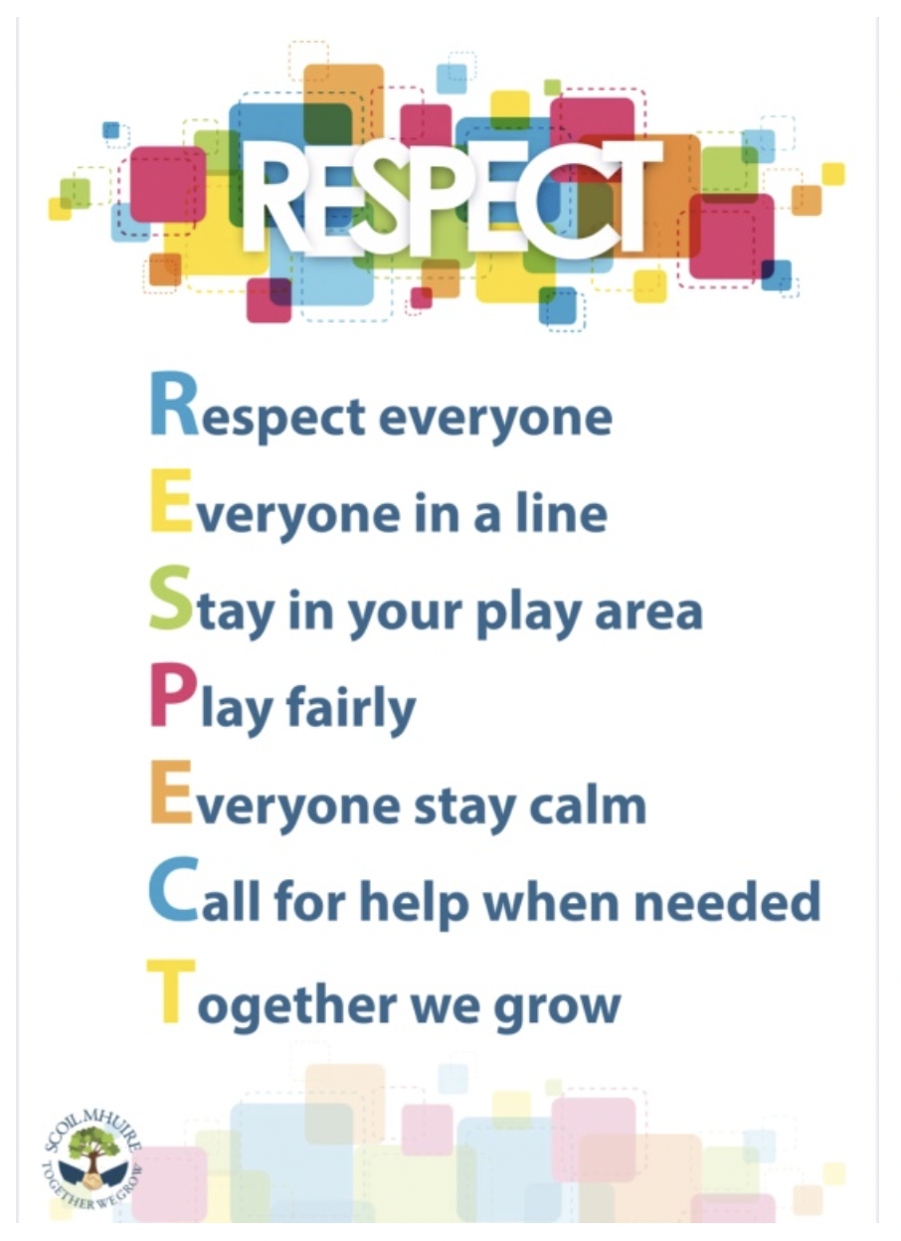
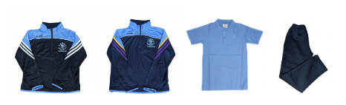
- Communicate progress and any concerns regarding behavioural and/or learning needs to parents/guardians

As a pupil I will
- Be on time for school
- Wear the full school uniform.
- Ear-studs only. Other piercings are not advised for health and safety reasons, taping
will be required. (Summer - knee length navy shorts)
- Show respect and speak kindly towards all peers, adults and school community
- Remember to use good manners by saying “Please”, “Thank you”, etc.,
- Be fair, kind, gentle and inclusive on the yard/AWS, follow the RESPECT Code
- Take responsibility for my actions and respect property (school or personal)
- Show forgiveness
- Listen to others/adults when they make suggestions, offer help or give advice or instruction
- Take part in all activities as best I can
- Complete homework as best I can
- Celebrate and be proud of all I do
When I follow these rules, I may receive Dojo points, Golden Time, certificates and go on class trips/ tours.

There will be times when I make a mistake or don’t understand the Code of Behaviour.
Should this happen, I may be expected to:
- Answer Restorative Practice questions to make things better with others
- Have another chance as long as I am not affecting anybody else
- Be reminded verbally by an adult of how I should behave and be warned of privileges that I might miss out on
- Listen to, read and/or discuss stories that help me understand my behaviour and how it affects others
- Give or write an apology, or to redo work if appropriate
- Be seated in a reflective space, moved seats, complete work in another classroom or removed from a play area if my behaviour affects others or if I am disrupting my own learning
- Follow a plan that has been made just for me, to help me to better understand how to behave
- Meet with the class teacher and my parent/guardian to discuss how to improve my behaviour
- Meet with the Principal/Deputy Principal and my parent/guardian to discuss how to improve my behaviour.
Our Code of Behaviour encourages our school community to be polite, caring, helpful, forgiving, behave respectfully, take responsibility and be inclusive for all.

