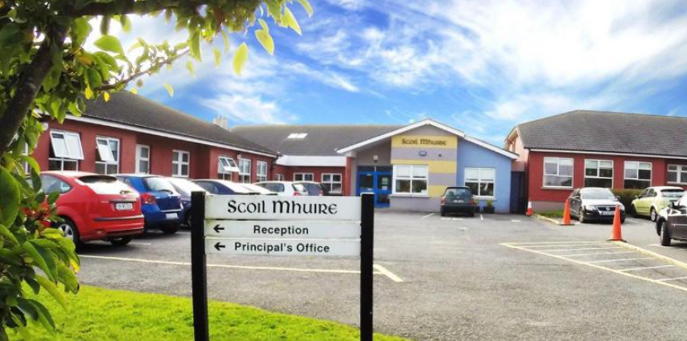

SMC Code of Behaviour
Summary for Staff & Visitors 2025-2026

Our Code of Behaviour focuses on a positive school community which promotes a welcoming, safe, caring and inclusive environment for all.

As a school we strive to:
- Care for our pupils’ safety and happiness
- Show respect to all and promote positive relationships

- Help our pupils to understand how and why everyone should behave well in school
- Listen to our pupils when they are finding something hard to understand
- Help our pupils to learn in the best way that they can and do their best
- Be flexible in supporting our pupils’ behavioural and learning needs
- Provide a broad and balanced curriculum
- Communicate progress and any concerns regarding behavioural and/or learning needs to parents/guardians. Pupils may receive Dojo points, Golden Time, certificates and go on class trips/ tours
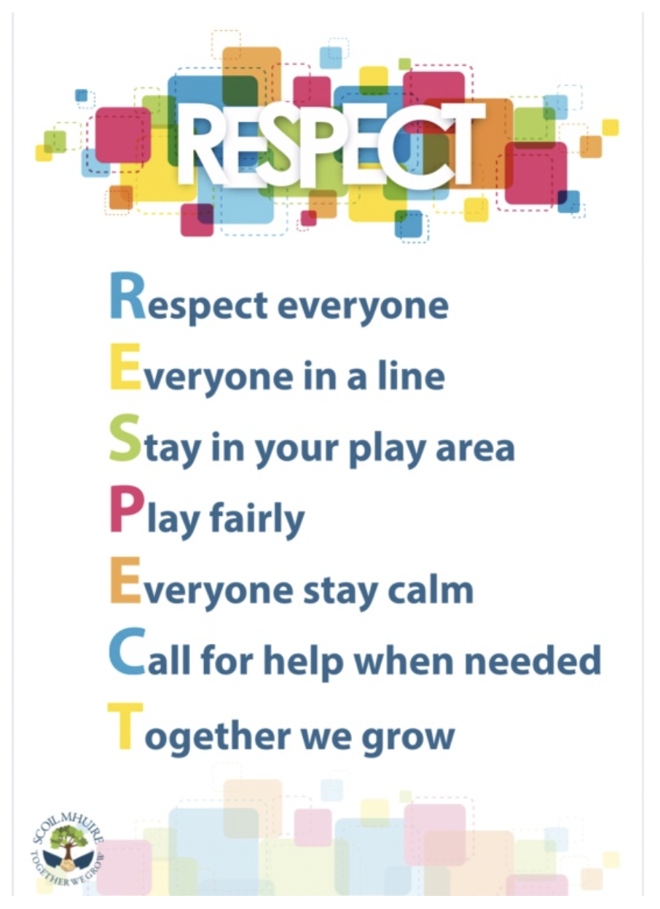
Pupils are expected to:
- Be on time for school
- Wear the school uniform (Summer - knee length navy shorts)
- Ear-studs only. Other piercings are not advised for health and safety reasons, taping
will be required.
- Show respect and speak kindly towards all peers, adults and school community
- Remember to use good manners by saying “Please”, “Thank you”, etc.,
- Be fair, kind, gentle and inclusive on the yard/AWS, follow the RESPECT Code
- Take responsibility for their actions and respect property (school or personal)
- Show forgiveness
- Listen to others/adults when they make suggestions, offer help or give advice or instruction

- Take part in all activities as best they can

- Complete homework as best they can
- Celebrate and be proud of all they do

Parent/guardians are expected to:
- See that their child goes to school everyday and on time
- See that their child wears the school uniform. Ear-studs only. (Summer - knee length navy shorts)
- Encourage their child to be independent and carry their own belongings
- Encourage their child to care for personal needs and belongings (coats, lunch boxes, water bottles etc.)
- Support their child with homework
- Make an appointment through the office to let the school know of any queries or questions they might have
- Send a message on Dojo or contact the school office if their child is not in school
- Communicate with the teacher via Dojo and understand that during the day, the teacher is teaching and will respond in a timely manner
- Speak kindly towards all children, adults and school community
Suggested Rules to be displayed in class
Whole-school approach | Classroom Rules
- Arrive to school on time - school starts at 8.50am  - Wear school uniform  - Remain seated during ‘wet duty’ recreation time  - Do not direct inappropriate/bad language at anyone  - Take all lunch leftovers home  - Walk in the corridors at all times  - Show respect in Assembly  - Line up appropriately on the yard  - Inform an adult or ask for help if unsure  - Stop, think, walk away  - Follow Classroom rules | - Use an inside voice at all times  - Listen to each other  - Walk in the classroom  - Keep water bottles in bags  - Go to the toilet one at a time  - Check the floor at hometime  (This list is not exhaustive and may be added to by the class teacher)

How to Promote Positive and Appropriate Behaviour in the Classroom:
- Understand your duty of care towards all pupils
- Put the pupils’ best interests first and understand the human rights of each pupil
- Discuss and display clear classroom routines, rules/agreements and clearly defined consequences (i.e. expected behaviour)
- Discuss and display clear School Rules
- Always follow-up on behavioural incidences with or between pupils
- Be reasonable and proportionate when considering consequences
- Consider the risk of doing something versus the risk of doing nothing
- Why does this behaviour/incident matter?
- What is the primary behaviour?
- Teach the RESPECT code, for behaviour on yard
- Teach, through SPHE, how to treat yourself and others well
- Display work and achievements in the classroom/corridors/assembly
- Award Dojo points, stickers, stamps, certificates, trophies to promote appropriate behaviour
- Use social media and assemblies to celebrate and acknowledge good efforts
- Inform parents/guardians//Deputy Principal/Principal when appropriate of positive/inappropriate behaviours

TiTips on How to Approach Challenging Behaviour with Pupils:
- Talk privately and give undivided attention
- Use language that is positive, simple and familiar
- Remain flexible, consider taking some time before discussing the problem etc.
- Model emotional control by being clear, calm, reasonable and non-judgmental
- Allow time and space for pupils to speak/explain/reply
- Avoid powerplay - focus on feelings, not just the facts
- Practise scripted responses - use restatement of expectations/rules to clarify messages
- Listen with empathy - allow silence for reflection
- Focus on building a positive relationship

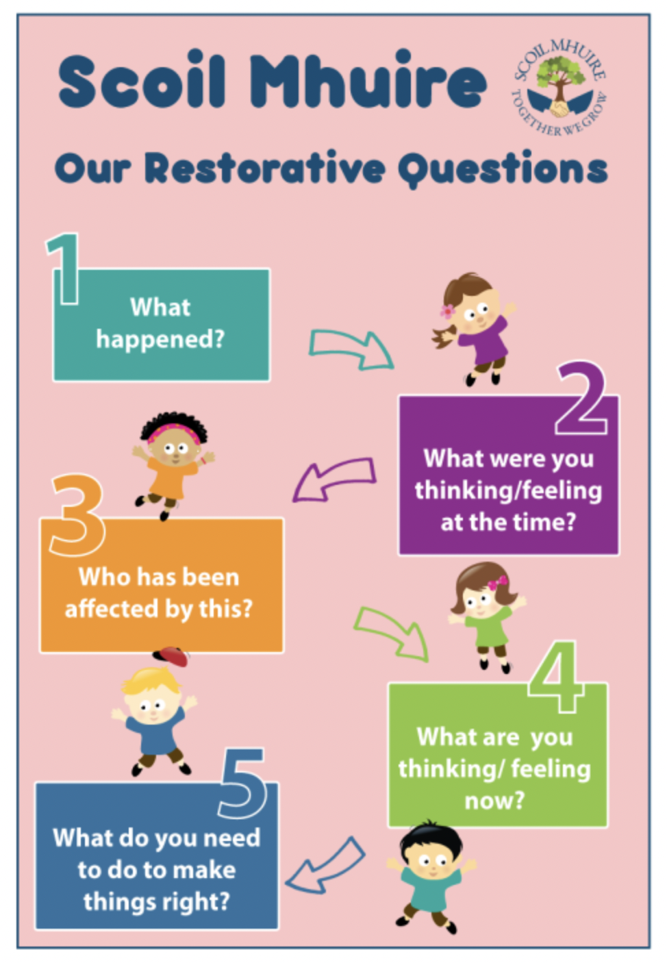

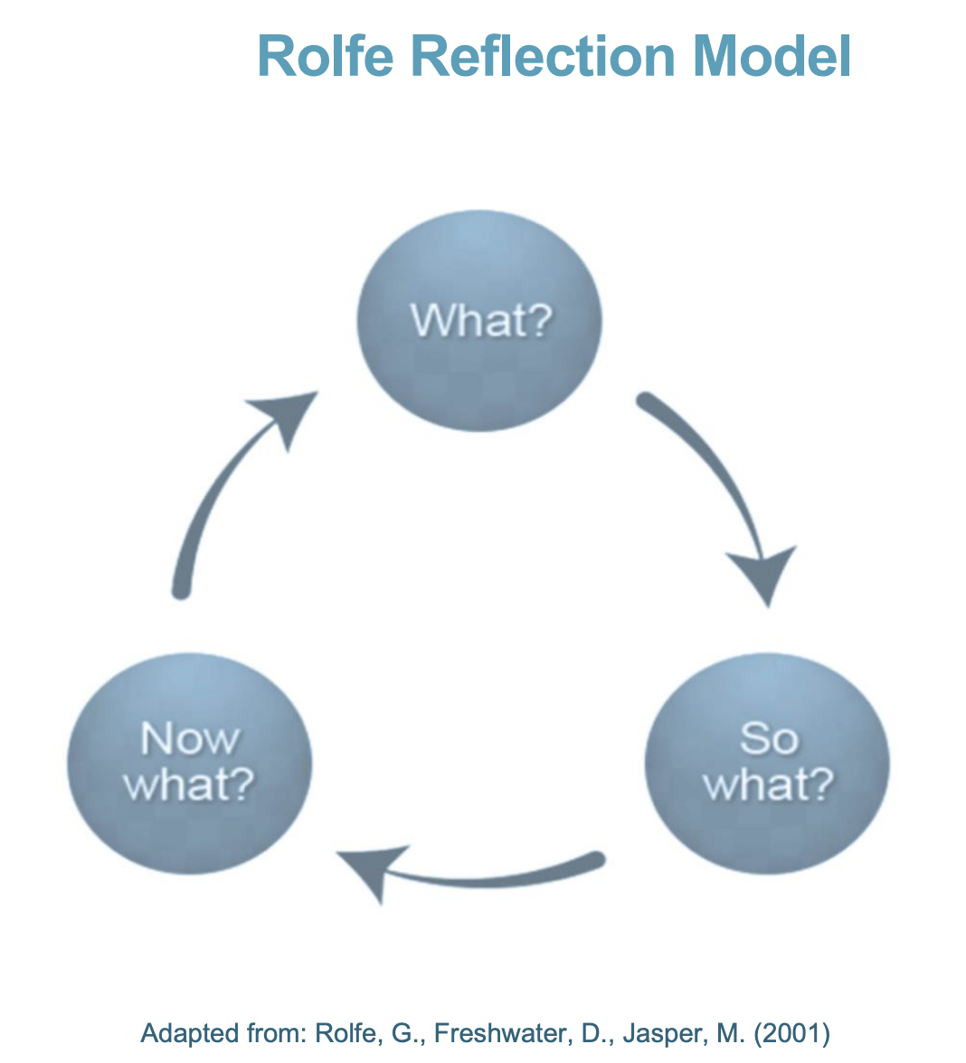

What:
• is the issue/problem?
• was my role in the developing situation being reflected upon?
• was I trying to achieve?
• actions were being done towards the achievement?
• were the responses of other people?
• were the consequences for the learner/s?
• were the consequences for me?
• were the consequences for other people?
• feelings were provoked in the student/s?
• was positive about the experience?
• was negative about the experience?
• could be improved?
So what:
• is important about this?
• more do I need to know about this?
• other approaches might I have tried?
• might I have done differently?
• have I learned because of this?
• issues have been brought to light by this situation?
Now what:
• could I do?
• do I need to do?
• should I ask of others to support me?
• do I need to avoid in future?
• have I learned?
• will I recognise in advance?
• broader issues need to be considered if the new set of actions are to be enacted?
• wider considerations need to be addressed?
There will be times when a pupil will make a mistake or not understand the Code of Behaviour.

Pupils may be expected to:
- Answer Restorative Practice questions to make things better with others
- Get another chance as long as it is not affecting anybody else
- Be reminded verbally by an adult of how they should behave and be informed of privileges that they might miss out on
- Listen to, read and/or discuss stories that helps them understand their behaviour and how it affects others
- Give or write an apology, or to redo work if appropriate
- Be seated in a reflective space, moved seats, complete work in another classroom or removed from a play area if my behaviour affects others or if I am disrupting my own learning
- Follow a plan that has been made just for them, to help them to better understand how to behave
- Meet with the class teacher and my parent/guardian to discuss how to improve my behaviour
- Meet with the Principal/Deputy Principal and my parent/guardian to discuss how to improve my behaviour

Nurture Principles:
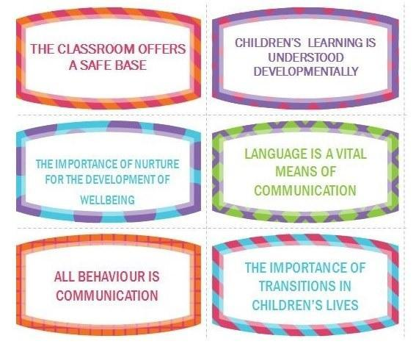

Ladder of Intervention:

Step 1. Most pupils behave appropriately with firm, consistent reminders of expectations/rules
- Use non-verbal hand signals, change tone of voice or stop and wait for attention
- Praise a pupil behaving appropriately
- Give a simple, fair verbal reprimand
- Overlook or ignore inappropriate behaviour that is not affecting others
- Move a pupil to another seat or classroom
- Remind class of expected behaviour
- Speak to the pupil privately about personal behavioural expectations/targets
- Reason with the pupil using problem-solving techniques and/or a warning system

Step 2. Some pupils require individual targets, a Behaviour Support Plan (devised with SET/SEN Coordinator), referral to the Pupil Support Team or referral to another teacher/adult
- Gather information to try to understand the context and factors that might be affecting behaviour
- Involve the pupil and parent/guardian to help to generate possible solutions
- Agree on specific strategies and implement them consistently
- Review the effectiveness of the strategies
- Make efforts to maintain a positive relationship with the pupil and parents/guardians
- Devise an emergency strategy for extra adult support, should pupils need to exit the classroom safely

Step 3. Occasionally a pupil requires sustained and systematic support from all the important adults in their lives (school and home): links with NEPS, Psychology Services, NCSE and CAMHS, may be made.

Sanctions help pupils to
- Learn that their behaviour is not acceptable
- Recognise the effect that their actions have on others
- Understand that they have choices about their behaviour
- Take responsibility for their behaviour
- Understand that the Code of Behaviour signals to others that their wellbeing is important, is protected and prevents serious disruption to teaching and learning
- Be kept safe

Scripted Intervention:
- I’ve noticed..
- This is the … time I have spoken to you
- You know our rule about…
- You will need to…
- Do you remember when you…
- Thank you for listening

Minor Behaviours  Dealt with by class teacher/SNA | Ladder of Intervention - Step 1
- Not lining up after the bell rings  - Moving around the school in a disruptive manner  - Running  - Shouting  - Groups  - General staff interaction (lack of politeness) | - Verbal correction/warning - talk individually to pupil, Restorative Practice  - 3 reminders if behaviour continues  - Time out & temporary separation from peers  - Report to class teacher if not in class  - Record and refer to Behaviour Team  - Follow up consequence or loss of privilege  - Contact parent (if staying in at breaktime)
- Not wearing school uniform  - Non completion of homework | - Verbal correction/warning - talk individually to pupil, Restorative Practice  - 3 reminders if behaviour continues  - Record and refer to HSCL if appropriate  - Sanction or loss of privileges or classroom rewards  - Contact parent
- Deliberate interruption of the smooth flow of the work of the classroom:  - Shouting out  - Making noises  - Arguing back  - Interfering with others work, property or person (RP)  - Distracting others  - Taking other people’s property  - Scribbling/marking other people’s work  - Littering  - Chewing gum  - Inappropriate facial piercings/jewellery | - Verbal correction/warning - talk individually to pupil, Restorative Practice  - 3 reminders if behaviour continues  - Time out & temporary separation from peers  - Follow up consequence or loss of privilege  - Record and refer to Behaviour Team for monitoring  - Contact parent (if staying in at breaktime)
- Undermining another’s self-esteem, through comments or behaviour (RP)  - Rough play (RP)  - Bad language not directed at anyone in particular (RP)  - Name calling (RP) | - Verbal correction/warning - talk individually to pupil, Restorative Practice  - Time out & temporary separation from peers  (or walk with supervisor if on yard/AWS)  - Follow up consequence or loss of privilege  - Report to class teacher if not in class  - Record and refer to Behaviour Team if repeated more than once  - Contact parent (if staying in at breaktime)

Serious Behaviours | Ladder of Intervention - Step 1 & Step 2  Potentially Step 3
- Repeated instances of minor misbehaviour  - undermining another’s self-esteem, through comments or behaviour  - arriving late for school  - rough play, bad language  - name calling  - not lining up after the bell rings  - littering  - chewing gum  - inappropriate facial piercings/jewellery  - not wearing school uniform  - non completion of homework  - Behaviour that is hurtful, including  - Bullying  - Harassment  - Discrimination  - Victimisation Fighting  - Hitting  - Kicking  - Spitting  - Pushing  - Name-calling  - Cursing  - Behaviour that consistently interferes with teaching and learning, threats or physical hurt to another person, damage to property, theft  - Arguing back (undermining authority) | - Verbal correction/warning - talk individually to pupil, Restorative Practice  - Time out & temporary separation from peers  - Follow up consequence or loss of privilege  - Report to class teacher if not in class  - Record and refer to Behaviour Team if repeated more than once  - Referral to Principal or Deputy Principal  - Assignment of additional work - What can I do to make it better?  - Contact parent  - Possible parent/teacher & Deputy Principal/ Principal meeting  - Behaviour contract  - Possible suspension & expulsion depending on level of seriousness and deliberate action.  - In the case of bullying refer to Bí Cineálta Procedures.

Inappropriate Behaviours | Ladder of Intervention - Step 1, Step 2 &  Step 3 where appropriate
Gross  - Assault on staff member or pupil- verbal or physical  - Serious theft  - Damage to property  - Immodest/inappropriate behaviour  - Bringing any article/item which could be of physical or moral danger to school  - Supplying illegal drugs to other pupils in the school  - Sexual assault | - Time out & separation from peers  - Immediate referral to the Principal or Deputy Principal  - Parent/teacher & Deputy Principal/ Principal meeting  - Possible suspension & expulsion depending on level of seriousness and deliberate action.  - As for Serious Inappropriate Behaviours  - Formal report to the Board of Management  - Suspension or Expulsion

Suspension & Expulsion:
Suspension may be Immediate or Automatic, in line with the pupil’s behaviour and may be deemed appropriate if
- The pupil’s behaviour has had a seriously detrimental effect on the education of pupils
- The pupil’s continued presence in the school constitutes a threat to safety
- The pupil is responsible for serious damage to property
- Constituted as serious breach of the Code of Behaviour
Expulsion is only considered in extreme cases of gross and/or repeated inappropriate behaviour. The Board of Management has sole authority to expel a pupil.

Our Code of Behaviour promotes clear rules, routines and boundaries, positive affirmations, positive incentives/rewards. It promotes and includes Restorative Practice, MAPA, our Nurture Room and a Pupil Support Team to manage behaviour and to create a safe learning environment. The Board of Management of Scoil Mhuire Coolcotts has adopted and fully complies with the requirements of Bí Cineálta Procedures to Prevent and Address Bullying Behaviour for Primary and Post ­Primary Schools June (2024).

We promote the six principles of Nurture across our school:
- The classroom offers a safe base
- Children’s learning is understood developmentally
- The importance of nurture for the development of wellbeing
- Language is a vital means of communication
- All behaviour is communication
- The importance of transitions is children’s lives.

Communicating The Code of Behaviour
The Code of Behaviour is addressed with pupils and staff through targeted classroom lessons, discussions, school assemblies and regular review. It is communicated to parents/guardians via The Home School Agreement and the Code of Behaviour Policy which is available through the school website https://coolcotts.com/code-of-behaviour

Ní neart go cur le chéile

